121/1 - MATHEMATICS ALT A - PAPER 1

MARKING SCHEME

END TERM EXAMINATIONS
Kenya Certificate of Secondary Education (KCSE)

 | CALCULATIONS | MARKS | REMARKS
1. | 133X0.51X1000000  0.19X0.0017X1000000  133X51X100  19X17  2100 | M1  M1  A1 | Multiplying  Correct …..  CAO
 |  | 03
2. | 2 48 72 100  2 24 36 50  2 12 18 25  2 6 9 25  3 3 9 25  3 1 3 25  5 1 1 25  5 1 1 5  1 1 1  L.C.M = 2⁴$×$3²$×$5²  = 3600  Number =3600 + 3  = 3603 | M1  M1  A1 | Correct lcm  Adding 3  CAO
 |  | 03
3. | 20 – x > 5+2x  15 >3x  x <5  5 + 2x ≥ x + 5  2x – x ≥ 0  3x ≥ 0  x ≥0  5> x ≥ 0  Integral values are 0, 1, 2, 3 and 4 | M1  M1  A1
4. | 5000 x 84.15  = 420,750  420 750  289 850  130 900  $\frac{130900}{80.43}$ = 1627.50  ≈ 1628 | M1  M1  1 CAO
 |  | 03
5  3cm  2cm  2cm  3cm  2cm  5cm  5cm  2cm | Surface area =  3 x 5 x 2 = 30  2 x 5 x 2 = 20  2 x 3 x 2 = 12  = 62cm² | 04 | B2 Check for other alternatives  M1  A1
6. | 2x - 1 - x² = 0  x² - 2x + 1 = 0  (x - 1) (x-1) = 0  x = 1 | M1  M1  A1 | Equating determinant to zero  Factorising
 |  | 03
7. | Diagram | B3 | Hidden lines visible
 |  | 03
8. | G+c=45  4g+2c= 100  G=45-c  4(45 – c) + 2c=100  180 – 4c +2c=100  C=40  g=5 | M1  M1  A1 | Forming the two equation.  Attempt to eliminate one variable.  For both
 |  | 03
9. | a) boys = 900 – 600= 300  ratio 3000:600  1:2  b) 300/900 x 100  331/3% | M1  M1  A1 | Getting the number of boys.  Should be simplified.
 |  | 03
10. | 4(t-1) – 3(4+t)=0  4t-3t – 4 – 12=0  t- 16 = 0  t= 16 | M1  M1  A1 | Attempting to remove fractions.  Removing brackets correctly.
 |  | 03
11. | (3marks)  = 0.2375 x 10¹  = 2.315  = 0.35 x 2.315  = 0.81025 | M1  M1  A1 | Correct reciprocal  Multiplication  CAO
 |  | 03
12. | 7y = 3x – 20  y = $\frac{3}{7}$x - $\frac{20}{7}$  g = $\frac{3}{7}$  Gradient of tar = $\frac{-7}{3}$  ∆y/∆x = $\frac{-7}{3}$  $\frac{y-2}{x-5}$ = $\frac{-7}{3}$  3y – 6 = -7x + 35  3y = -7x + 41  y = $\frac{-7}{3}$x + $\frac{41}{3}$ | M1  M1  A1 | rewriting in y = mx + C  or equivalent  or equivalent  3y + 7x = 41,  7x + 3y – 41 = 0
13. | diagram  x =  x = -15  = -15  - = 15  h  h(1-0.7813) = 15 h =  h = 68.58m | M1  M1  M1  A1
 |  | 04
14. | =  =  = | M1  M1  A1
 |  | 03
15. | Time taken 1600 h – 830 h = 7hrs 30 min  = 7hrs  Av. speed =  = 40km/h | M1  M1  A1
 |  | 03
16. | 3^{4(x+1}) +3^{4x} = 246  3^{4x+4} +3^{4x} = 246  3^{4x}(3⁴+1)=246  3^{4x}=246  81  3^{4x}=3¹  4x= 1  X=¹/₄ | M1  M1  M1  A1 | Accept the alternative.  Factorizing 3^{4x}  Equating powers  Accept 0.25
17. | - Original contribution =  New contribution =  Increase = =  =  =  - = 24  18000 = 24n² -120n  n² – 5n – 750 = 0  n² – 30n + 25n – 750 = 0  n (n – 30) + (25 (n – 30 ) = 0  (n – 30) (n + 25) = 0  n - 30 = 0  n + 25 = 0  but n cannot be –ve n = 30  - = 120 original  = 144 new  increase = = 20 % (10 mks) | M1  M1  M1  A1  M1  M1  A1  M1  M1  A1
 |  | 10mks
18. | 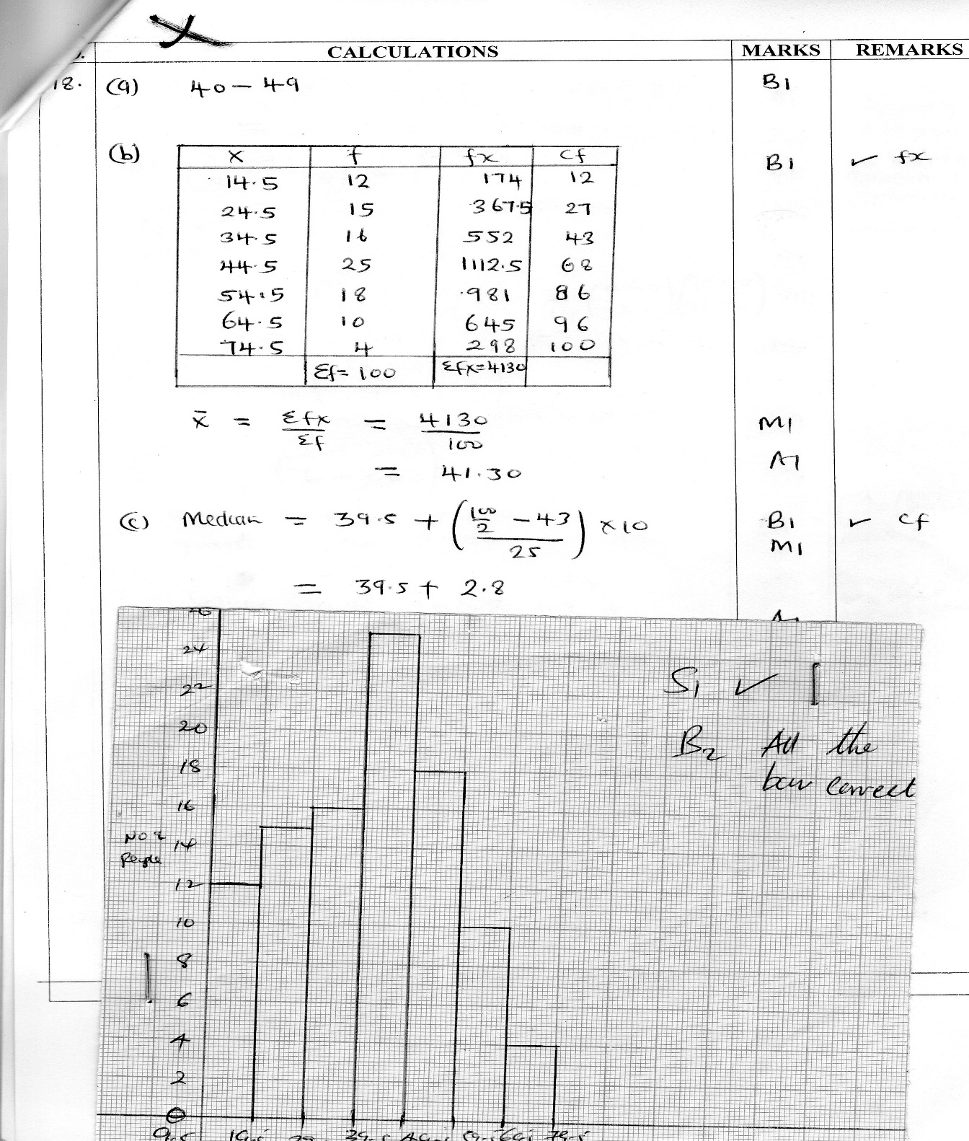 | M1  M1  M1  M1  M1  M1  M1  M1 | Mid pts  ∑f  fx  cf  Mean  Expression of median  median
. |  | 10mks
19 | 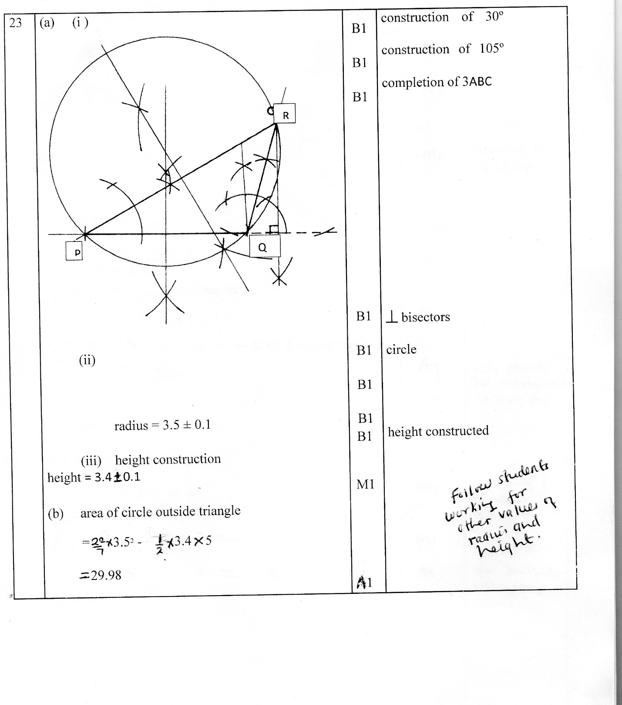  ii) Radius = 3.5 ± 0.1  iii) height construction  height = 3.4±0.1  b) area of circle outside triangle  = ²²/₇ x 3.5 – ½ x 3.4 x 5  = 29.98 | B1  B1  B1  B1  B1  B1  B1  M1  A1 | Construction of 30⁰.  Construction of 105⁰  Completion of ∆ABC.  1 bisectors.  circle  height constructed
 |  | 10mks
20. | a) i) v=3.142 x 3² x 12+12+²/₃ x 3.142 x 3³  =339. 336 + 56.556  = 395.892  = 395.9  ii) v= 15 x 6 x6 – 395.892  = 144.108  =144.1  b) i) S.A = 3.142 x 3² +2 x3.142 x 3 x 12 + 2 x 3.14 2 x 3²  = 28 .278 +226.224+56.556  311.058  = 311.1  ii) Cost = 311.058 x 900  8x1000  = ksh. 34.99  = 35.0 | M1  M1  M1  A1  A1  M1  M1  A1  M1  A1
 |  | 10mks
21. | 2.80cm  3.5cm  h  5cm  (a) Linear scale factor (L.S.F)  $\frac{2.8}{3.5}$ = $\frac{4}{5}$  Area scale factor (A.S.F) ($\frac{4}{5}$)² ⁼ $\frac{16}{25}$  Volume scale factor (V.S.F)  $({\frac{4}{5})}^{3}$ = $\frac{64}{125}$  From similar triangles  $\frac{h}{h+5}$ = $\frac{4}{5}$  5h = 5h + 20  h = 20cm  Length of larger cone  L² = 25² + 3.5² = 625 + 12.25  =637.25  L = $\sqrt{637.25}$  ∴ l = 25.24  Curved surface area larger cone  $πrL$ = $\frac{22}{7}$ x 3.5 x 25.24  = 277.64cm²  Curved S.A of the small cone  $\frac{16}{25}$ x 277.64 = 99.9cm²  Total surface area of frustrum  $\left\{\frac{22}{7} x 2.8 x 2.8\right\}$ + $\left\{\frac{22}{7} x 3.5 x 3.5\right\}$ + 99.95 cm²  24.64 + 38.5 + 99.95  = 163.09cm²  (b) Volume of small cone  $\frac{1}{3}r^{2}$h = $\frac{1}{3}$ x $\frac{22}{7}$ x 2.8 x 2.8 x 20 = 164.3cm³  Using volume scale factor (V.S.F)  Volume of larger cone  = $\frac{125}{64}$ x 164.3cm³  ∴Volume of frustrum  = $\left\{\frac{125 }{64}-1\right\}$ x 164.3  $\frac{61}{64}$ x 164.3  = 156.6cm3 | B1  M1  M1  M1  M1  A1  M1  M1  M1  A1 | Vsf  Height,h  Crved SA  Big Volm  Small volm  Volm of frustrum
 |  | 10mks
22. | Dist. AB = 112 × ⁵/₂ = 280km  BC = 75 × ⁸/₃ = 200km  AB = 7cm, BC=5cm, AD=4cm  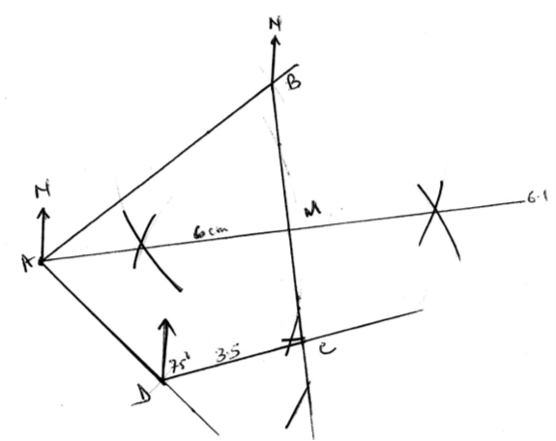  b) i) CD = 3.5 × 40 = 140KM  ii) Bearing of C from D is 075°  - i) AM = 6 × 40 = 240km  ii) Speed = ²⁴⁰/₂  = 120km/h | B1  B1  B1  B1  B1  B1  B1  B1  M1  A1 | Position of B  Position of C  Position of D  Complete route  Location of M  CD  Bearing  AM  Speed  CAO
 |  | 10mks
23. | - 64 x 0.5 = 32 km  384 -32 = 352 km  Time =  =  = 2.75 hrs  = 2 hrs 45 min  meeting time = 8.30 + 2.45  = 1075  = 1115 h or 11:15am  (b) D = S x T  = 64 x 2.75  = 176km  - At 10:30; time difference = 10.30 – 8.30 = 2 hrs  64 x 2 x 64 x 2 = 352  x = 352 – 256 = 96 km apart | M1  M1  M1  M1  A1  M1  A1  M1  M1  A1
 |  | 10mks
24. | 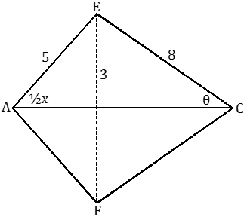  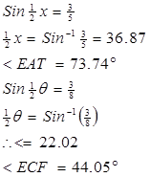  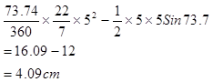  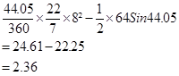  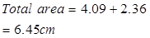 | M1  A1  M1  A1  M1M1  A1  M1  M1  A1
 |  | 10mks

